A single light

In the wide dark

-by bassam alhejaji

CHAPTERS:

1. ...............a mysterious knowledge
2. ……………..switch off
3. ……………..where we lose hope
4. ……………..could I be your…….enemy?
5. ……………..the smirk
6. ……………..what the cover hides
7. ……………..the last shine
8. ……………..on our knees we fall
9. ……………..a single light
10. ………………in the wide dark

CHAPTER 1

A mysterious knowledge

Once there was a city with a given name of “**crimson city**”, you may think that the people of this city were having a happy life, not all the stories are happy ones, the people were wearing masks that prevented them from talking and kept them prisoners to desperate and sadness, That is because the city was swallowed by dark powers made all the people forget happiness, it was guarded by creatures called “**consumers**”.

Imagine bodies covered with blurred shadow, striking the living with fear, screams of agony calls upon your death as they get closer to you, Those real powerful creatures owns an ability to teleport, they’ll kill any human that disobey them, the only rule that they fallow is “*destroy any light source*”.

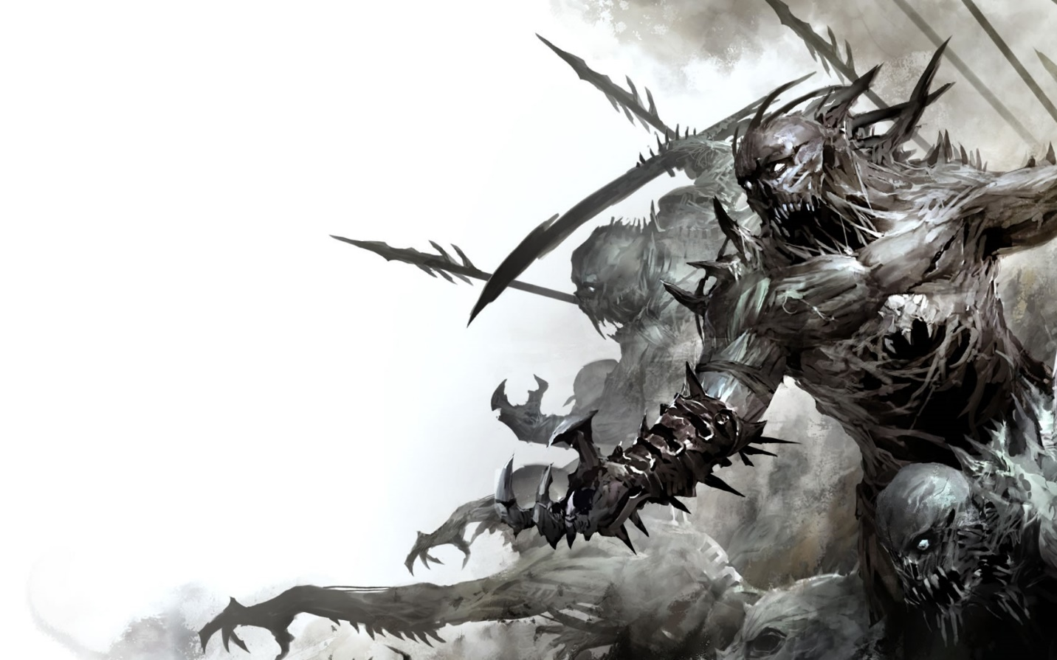

Covered by the black color, the city didn’t know what light means; because the city is beneath the land , “**crimson city**” haven’t seen a single light , not the sun light , not the fire light , neither the stars light.

But not every light shines.

The city had an orphan girl named “**hope**”, she’s 14 years old, sure she is sad, but also the most curious human in the city, she always love to discover the mysterious little things, but discovers them with empty feelings because of the mask.

walking in the city streets between anonymous people wearing the face of the blinded life, **"hope"** found a black cabin with a broken sign, she haven’t seen this cabin before even though she knows the street very well, she entered the cabin, it was like a mix of sadness and fear, the first thing she noticed in the cabin was a strange white glass table with a piece of a white paper on it, it was the first time she sees a color like this, she hesitantly approaches the table, she picked up the paper with a scared shivering hand, the paper was empty, and from the nowhere a “**consumer**” appeared and threw “**hope**” on the table, the table was shattered into pieces.

As the “**consumer"** picked her up on his shoulder, she took the paper and a piece of the table’s glass, as the **"consumer"** was walking in silence, "**hope"** tried to stab him with the glass piece but it only went through the body with no use, she was screaming for help, but the people just stared at her with empty eyes and few other ignored her, the “**consumer”** entered a building and walked down stairs, it was getting colder the more he walked down, then he stopped, it was dead silence, only the heavy breathing of hopes fear was heard, the **"consumer"** threw “**hope”** into a room.

The room was so cold and silent, she was shaking non-stop, suddenly she heard a strange sound, she heard something approaching, she thought it was another “**consumer**” that came to kill her, but it was cat, it was the first time that she gets this close to it, she felt a little bit of comfort, she started to pet it, she felt warm, all of sudden, she noticed a little shin in the cats eyes, she was amazed; because the shin was so colorful, second by second the shine started to fill the room, she felt frightened because she never seen such a bright light, a warmness in her pocket made her stop moving in fear, she took out the paper and looked at it ,the shin got threw the paper and reveled a message with a sketch of bugs.

The message said:

“Hope…..I’m so sorry we left you, it was something we had to do, because if I didn’t, “**crow**” would’ve done the worst, it kills us knowing that you haven’t seen the light. So we created “**shine**” for you, when you find “**shine**” he will tell you everything…..we are so sorry sweet cheeks……daddy loves you”.

**Hope**'s heart sank in her stomach, she was shocked by the fact that her father wrote this message.

**Hope** felt like there is a word that she wants to say, she have never spoken a single letter before, so it was hard for her to say that word.

As the room got brighter and brighter, hope said the first letter of the word.

**Hope**: d………d….

She felt like she was restored

By collecting her calm, the word was reveled

**Hope**: da…….d…..daddy?

**Hope**'s mask slightly cracked as if she broke free from a chain that was holding back her true potentials

The bugs sketches came to life and flew of the paper, the whole room shined so bright and colorful!

Book shelfs and a TV screen appeared in the room, a bed mattress with 2 pillows was also there, but hope was only focused on the bugs, she never seen such creatures before

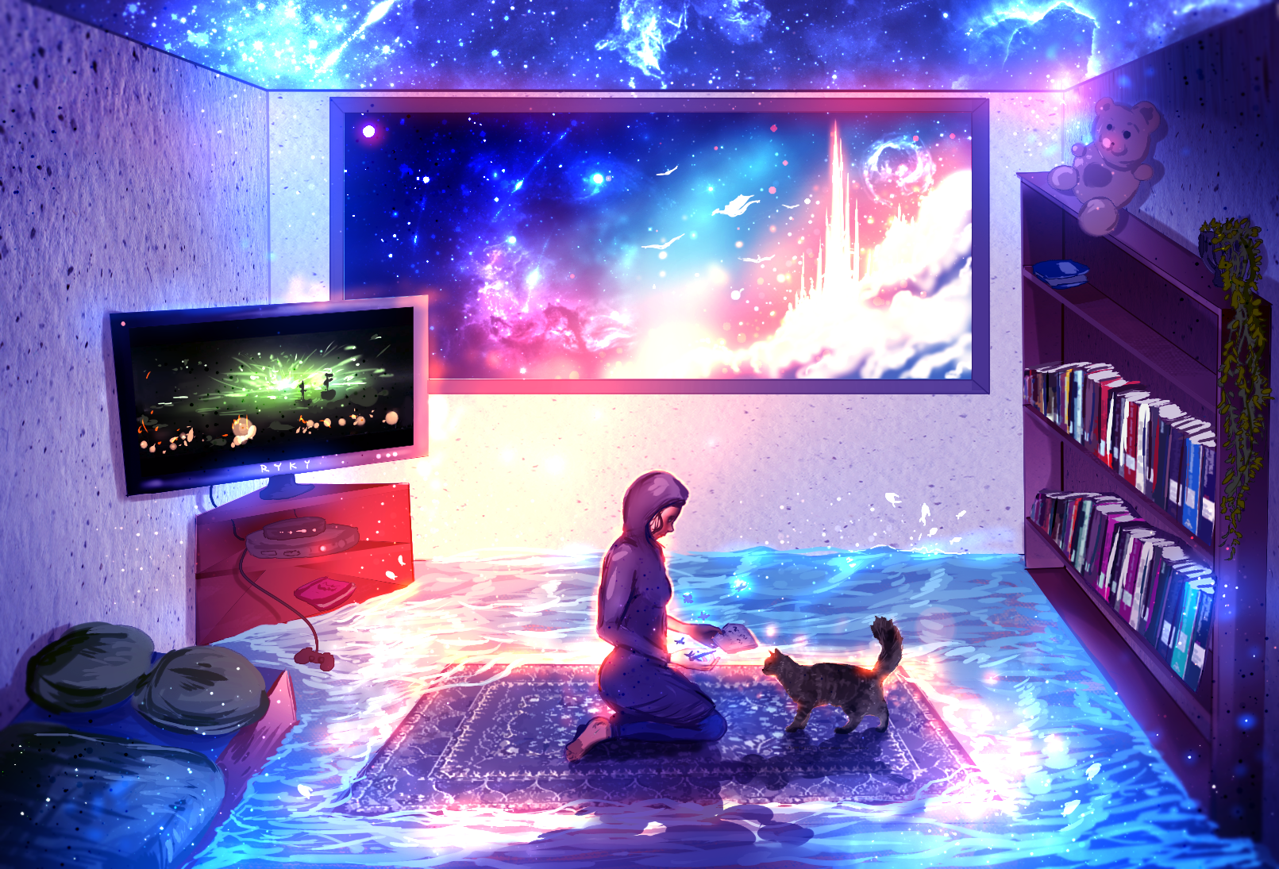

**???** :So you finally learned how to speak

An unknown being spoke, hope flinched

**Hope**: who’s speaking?

**Shine**: I’m “**shine**”……the creature that your dad mentioned in the message

**Hope**: WHERE ARE YOU?!

**Shine**: LOOK DOWN STUPID!!!!

As **hope** looked down, she knew that **shine** was the cat that the light came from.

**Hope**: you can talk?!

**Shine**: sigh……I’ll explain everything

**Shine**: your dad’s name is ____, he created me preparing for the worst, he knew that you where something special, you weren’t like all the people, you have some amazing potentials, still……you haven’t figured it out didn’t you?

As **shine** mentioned **hope**'s father name, hope couldn't hear it; because whispers prevented her from hearing the name clearly.

**Hope**: can you repeat the name please?

**Shine**: _____, is there a problem **hope**?

**Hope**'s attempt to hear her father's name was useless, the whispers wouldn't allow her somehow

**Hope** stared at shine in silence

**Shine**: jeez, I'll write it down for you

He went towards the wall and started to scratch the name on the wall with his claw, after he moved away, **hope** only saw a smudged word bleeding a black smoke

**Hope**: I can't see what's written

**Shine**: you must be-

Suddenly, **shine**'s eyes opened wide, heremembered something that he was afraid of.

**Shine**: wait…it can’t be….

**Hope**: WH….what is it?!

**Shine**: **hope**, can you remember your best friend, _____?!!

**Hope**: I can’t hear the name!

**Shine**: so **crow** really did it……..that little wheat bag!

**Hope**: who’s **crow**? And why can I hear your name and his only?

**Shine**: **Crow** cursed you, you will not be able to hear or read the names of specified people like your father and your best friend, if you attempted to read or hear the names, the curse will immediately smudge the characters and blur your hearing

**Hope**: how can I know their names?

**Shine**: by hearing their names from them personally, the curse of each name shall be broken

**Hope**: but why are the names blurred? What's the reason?

**Shine**: jeez, you ask too much for a 12 years old girl

**Hope**: I'm 14!

**Hope** said with an angry tune

**Shine**: sigh, the names are blurred because every name holder will restore some of your memories, also may grant you some knowledge and feelings

**Hope** thought, if she heard every name, she will finally know who she really is.

**Shine**: we need to find a way out of this room….. I think we could trick the **consumer**

**Hope** knew this will be a real risk, especially that the **consumer** can teleport extremely fast

**Hope**: how? He’ll catch us at the moment we run

**Shine** proudly giggled.

**Shine**: and who said anything about running?

**Shine** released a small hovering light aura and made it fly through the door’s key hole, they heard the sound of a **consumer** striking the wind behind the door

**Shine**: now then, shall we escape?

**Hope** stood on her feet, not knowing that when she grab the knob, she grabs her new adventure, she opened the door, pushing it slowly forward, her heart beat got faster as the door creaked.

**Shine**: don’t worry, the **consumer** isn’t coming back for the next 10 mins

As they escape, **shine** noticed that hope is trembling while walking, looking like she’s going to collapse.

After they escaped and found a safe place, **hope** started to cry, but the mask hidden her expressions, tears leaked from the mask's eye

**Hope** talked with a sad quite tune in her voice, **shine** was quite

**Hope**: what is this feeling in my heart, it's painful

As the mask was cracked, **hope** restored few of her feelings, like crying and feeling anger.

As sadness crawls up on you, you feel like your heart got heavier, your limps got weaker, and pain in your eyes as tears burst, as tears fill your eyes your vision gets blurry like you can't see or understand a thing, that's a reality **hope** lived for 14 years.

**Hope**: I’m sorry, it just hurts.

**Hope** tried to speak, but her heart was killing her, so she took a shivery gasp between few words

**Hope**: it hurts knowing I was hiding under the clock of a lie, I lived my whole life believing that my parents left me, BELIEVING THAT THEY HATED ME!

It’s amazing how words can describe the person, **Hope'**s words cracked their way to **shine**'s heart

**Shine**: h-hope, it’s not your fault

**Hope**: YES IT IS!!

**Shine** couldn't say a word, he turned around and saw a man wearing a mask staring at them, **shine** realized this man was suffering, he realized this man felt nothing but fear and emptiness, he imagined **hope** like this, and he felt regretful and powerless.

Hearing **hope**'s cries,as he was looking at the man, **shine** said

**Shine**: the last time I saw your father, he told me, "*you were given this life because you are strong enough to live it*, *you don't always wait for the perfect time, sometimes you must dare yourself to jump*, *you and* ***hope*** *are braver than you believe*, *stronger than you seem, and smarter than you think*".

**Hope**'s crying started to fade away, the man continued walking, **shine** softlygiggled

With a giggly tune in his voice **shine** said

**Shine**: he sure is clumsy and sarcastic sometimes, I remember when he stepped on my tail and made me rip his pillow as a revenge

**Shine**: but also, he is the smartest and wisest that I have ever seen, that is beside his pure love to you and your mother, now tell me, what shall you do as a repay for your parents trust and love towards you?

A moment of silence filled the place

As **hope** collected her calm and wiped her tears, she slowly stared forward, her voice got mixed with anger and sadness

**Hope**: shine…

**Shine**: y…yes?

**Hope**: take me to my parents, I'll try to do everything-no!, I will do everything in my powers to find them, no matter where the journey takes me, no matter how much I risk my life, I shall find them!

**Shine** felt **hope**'s anger, he took one step backward

**Shine**: it looks like we are going to the top, which means a lot is waiting for us

**Hope**: the top?

**Shine**: crimson city is land that is under seven other lands, the top is where you were born, it's a kingdom, and your father and mother were the king and queen

**Hope**: that means I'm royal family

**Shine** got surprised that **hope** figured it out

**Shine**: how did you know?!

**Hope**: looks your name restored some of my knowledge and feelings

**Shine**: oh…right

**Shine**: now then shall we go?

**Hope**: let's go

With Feelings and memories sealed away, sparks of fire welding in her heart, **hope** knew that the journey is long, but she didn’t care about the distance or risks, all she cared about is the safety of **shine** and finding her lost parents, but what she didn't knew that a lot of enemies and friendships are ahead, a lot of unknown danger is going to take over the seven land above, but determination only made her stronger.

END OF CHAPTER ONE